WELCOME TO THE BLACK BEARS
We are very excited to welcome you to the Black Bear Team at LMS. In seventh grade, you will be acquiring the skills of a good learner which will be very important as you move through LMS and on to CHS. As we begin a new school year, we encourage you to be invested in your learning. The more accountable you hold yourself to high academic standards and practice them on a daily basis, the more you will get out of your experiences at LMS.
We expect that students will enter seventh grade with good learning habits. One of these important habits is to complete homework in a timely manner. Homework reinforces the concepts and skills taught in class and is vital to academic success. The thoughtful completion of homework will help you to achieve better grades and to gain confidence in all subject areas. All homework assignments will be recorded in your agenda daily. As an additional support, all homework assignments will be listed on Infinite Campus each day.
The following is a list of materials that you will need for most of your school work for seventh grade:
- Free read books
- Folders for each subject area
- Graphing spiral notebook for mathematics
- Separate three ring binders for mathematics and science
- Blue or black pens
- Pencils/ Erasers
- Highlighters
- Glue stick
- Composition notebook for science
- Red pens for correcting
- Colored pencils
- Ti 34 Multiview Calculator
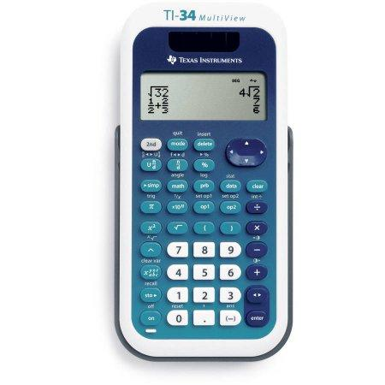

Seventh Grade Teachers:
Kim Nolan – Language Arts Shea Bishop – Mathematics
Sarah Damon– Science Audra McCollem – Social Studies
Jody Corbett – Mathematics

Unified Arts:
Semester one – Computers Semester two – Tech Ed.

Quarter one – Art Quarter two – FACS Quarter three – PE Quarter four - Health

We are looking forward to an exciting, successful, and memorable year. We will see you in September!

The Black Bear Teachers

